日本マイクログラビティ応用学会誌 (JASMAC Proceedings) 原稿作成用テンプレート
○微小一郎，生命花子，流体次郎 (燃焼大学)，細胞三郎（株式会社プラズマ)

Template for Journal of the Japan Society of Microgravity Application(JASMAC Proceedings)

Ichiro BISHO, Hanako SEIMEI , Jiro RYUTAI (Combustion Univ.), Saburo SAIBO (Plasma Co., Ltd.)

1. Layout
The manuscript should be typewritten in English on one side of A4 paper. The standard font in this template is serif such as Time New Roman or Times (9pt). Left and right margins are 25 mm, Top 30 mm, bottom 150 mm. The main body should be formatted in two columns with justification. The gap between the two columns is 7.5 mm.
This template is provided for JASMAC Proceedings Half Page style. The recommended word processor for this template is Microsoft Word. For authors’ convenience, styles starting with JASMAC are defined in this template. If authors want to use other word processors or text formatters, please copy all the layout of this template as closely as possible.

2. Forms
2.1 Headings
The headings have sequential numbers such as 1(10pt). for the section headings, 1.1(9pt) for the subsections and 1.1.1 for the sub-subsections.
2.2 Other Forms
Please refer to “JASMAC Proceedings template Full Page Style” for other forms as follows.
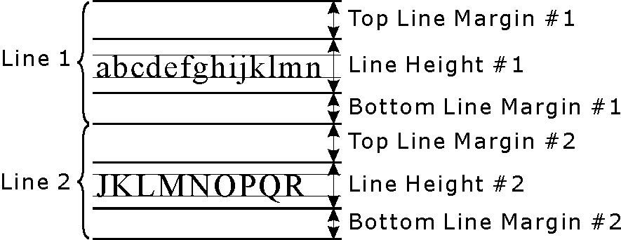
Fig. 1 This is a sample of a figure
References
- The author names, a colon as a separator, the journal name, the volume number, the issue number, the publishing year in parentheses, the starting page. All authors are included in the author names (do not use et al.). The Volume number is expressed in bold fonts (8pt).
2） A. F. Witt, H. C. Gatos, M. Lichtensteiger, M.C. Lavine and Herman: J. Electrochem. Soc., 122 (1975) 276.

