Reserved Space for Title of Special Articles
Reserved Space for Kind of Articles
Template for Submission to J. Jpn. Soc. Microgravity Appl.
(For Original Articles, Report, Review or Research Note)
Ichiro BISHO ¹, Hanako SEIMEI ¹, Jiro RYUTAI ¹,
Saburo SAIBO ¹, Tsukiko KESSHO ¹ and John COMBUSTION ²
Abstract
Manuscript should be typewritten in English on one side of papers, size ISO A4. The abstract length must be no more than 910 characters including spaces. 5 or less keywords should be described just below the abstract. This template is provided for preparation of manuscripts of original articles, reports, reviews or research notes. To prepare the manuscript using Microsoft Word, please use this template as it is. Otherwise, please copy the page layout as closely as possible. A 14 pt serif font such as Times New Roman or Times with a bold face should be used for the title. An 11 pt serif font is for the author names. 8 pt bold serif and 8 pt serif are for the abstract heading and the abstract body, respectively. The footnote should be written in 8 pt serif. An 11 pt sans-serif font such as Arial or Helvetica is for the section headings. 10 pt sans-serif is for the headings of the subsection or lower levels. The main body should be presented in 9 pt serif.
Keyword(s): JASMA, journal, template
Received 12 Feb. 2015, accepted 24 Mar. 2015, published 31 Apr. 2015

1. General Layout
1 Department / Division / Faculty , Organization / University, Address
2 ...
(E-mail: e-mail address of the corresponding author, e.g., Bisho.Ichiro@jasma.jp in this template)
This area is created as a table. The top, left and right margins of this table are 1 mm, 2 mm and 2 mm, respectively. Please describe affiliations of authors, addresses in this area. The font face and the font size are serif such as Times New Roman and 8 pt, respectively. The line height should be fixed as 1 line. The hanging indent should be set at 5 mm. We recommend tables instead of footnotes if Microsoft Word is used since the footnote takes excess space and the length of the upper boundary line does not match the style of the journal of the JASMA. The length of the upper boundary line must be 172 mm (same as the total width of two columns in the main body). The e-mail address of the corresponding author should be added to the next line of the affiliations with parentheses. Styles for the Microsoft Word users, named “JASMA_Footnote” and “JASMA_Footnote_Mail”, are provided for assistance.
This template is provided for Microsoft Word 2007 or later versions only. The manuscript should be typewritten in English on one side of ISO A4 paper (210 mm in width and 297 mm in height). The line height of the main body should be fixed at1.27 lines. Top, bottom, left and right margins of each page are 29, 30, 19 and 19 mm, respectively. The main body should be formatted in two columns with justification. The gap between the two columns is 7.5 mm.
This template is used for preparation of manuscripts of original articles, reports, reviews or research notes submitted to the Journal of the Japan Society of Microgravity Application (JASMA). Please save the document as the docx (native mode) format. If authors save the old doc format, the editorial board will reject the submission and request the format conversion to docx. If authors try to express some equations, the standard equation editor of MS-Word 2007 or later versions should be used. For authors’ convenience, styles starting with JASMA are defined in this template. If authors want to use other word processors or text formatters, please copy all the layout of this template as closely as possible.
The standard font in this template is serif such as Time New Roman or Times. A sans-serif font such as Arial or Helvetica will be used for headings. The standard symbol font is Symbol. Other fonts may not be acceptable. If authors want to use special fonts for a certain reason, they must be pasted as images of more than 300 dpi to the manuscript.
Headers and footers are typewritten on all the pages but authors are not required to take care of them. The editorial board of the journal of the JASMA will describe the headers and footers. The publication information, the title and the first author will be inserted into the predefined location as the headers. Page numbers and the publication information will be inserted as footers.
2. Title Part
2.1 General
The title part consists of the title, author names and an abstract. The title part should be located at the first page. Affiliations of authors also must be described at the end line of the title page. Organizations, division / department names, addresses should be included in the affiliations. An e-mail address of a corresponding author is also described on the next line of the affiliations in parentheses. If authors use an abbreviation in the title, the full name should be added just after the abbreviation in parentheses, for example, BFC (Boundary Fitted Coordinates) method or GHF (Gradient Heating Furnace). For well-known abbreviations such as RF (Radio Frequency) or TV (Television), it is not necessary to add the full name.
2.2 Margins and Columns
The title part is formatted as one column. Additional 5 mm margins on the left and right sides are added except for the reserved first two lines. Thus, the left and right margins at the title part are 24 mm.
2.3 Format
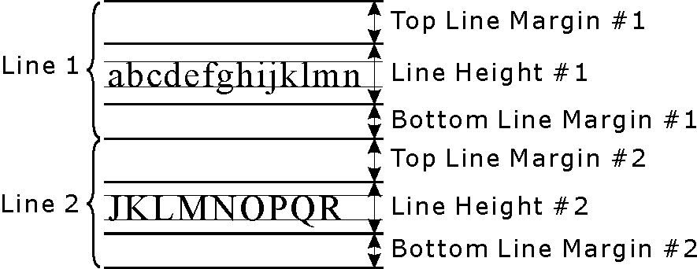
Fig. 1 Definition of line height and line margin
2.3.1 First Two Lines
Two lines of a fixed line height of 4 mm are reserved by the editorial board (8 mm in total). A title of special articles will be described in the first line. The type of articles will be expressed in the second line. Authors are not required to describe anything on these two lines. If authors accidentally change line properties such as line height, they can be recovered by applying the style named “JASMA_Special_Article” but only if they are Microsoft Word users.
2.3.2 Titles
The titles should be concise. The first letter of the first word should be capitalized. Capital letters are used at the beginning of second and later words except for articles, coordinate conjunctions, forms of to be, “to” as the beginning of an infinitive phrase and prepositions of 3 letters or less. If the preposition is part of a two-word verb, the beginning of the preposition is capitalized even though its length is less than 3 letters. The fonts are bold 14 pt serif fonts. The line height is fixed at 14 pt. Each line must be centered. There are two kinds of line margins on the top, that is, 7 mm for the first line and 2 mm for the others. Definitions of the line height and the line margin in this template are shown in Fig. 1. Authors using Microsoft Word can use a style named “JASMA_Title” for the first line or “JASMA_Title_Cont” for the second line or thereafter.
2.3.3 Author Names
Author names are included after the title lines using 11 pt serif fonts with centering. The line height is fixed at 11 pt. The top line margin is set to 8 mm for the first line and 2 mm for the others. The author names are positioned so that the first name comes first and the family name comes last. The first letter of the first name is capitalized, however, the family name is in all capital letters. If the authors do not belong to the same affiliation, superscripted Arabic numerals will be added at the upper-right position of the name to clarify the affiliations. The affiliations are included in a footnote area, which will be explained in subsection 2.3.4. Styles named “JASMA_Author” for the first line and “JASMA_Author_Cont” for the other lines are available for authors using Microsoft Word.
2.3.4 Footnotes
The footnote area is located at the bottom of the first page. The length of the footnote separator is the same as the main body area, that is, 172 mm. In order to create a separator line, it is strongly recommended to the authors using Microsoft Word to use a table. Margins outside the table are 1 mm on the top and 0 mm on the other sides. In addition, margins inside the table cells are 1 mm on the top, 2 mm on the left and right sides, and 0 mm on the bottom.
First, the Arabic numeral corresponding to the one on the upper-right side of the author is described. The affiliation includes a department name, a division name, an organization name and an address. Each line is formatted as a 5 mm hanging indent. After all of the author affiliations, the e-mail address of the corresponding author is included in parentheses without indentation. The authors using Microsoft Word can use styles named “JASMA_Footnote” for the hanging indent and “JASMA_Footnote_Mail” for the e-mail line.
2.3.5 Abstract
Abstracts are required in manuscripts of original articles, reports, reviews or research notes. The abstract consists of one paragraph. Authors should write a heading for the abstract using bold 8 pt serif fonts with a fixed line height of 8 mm. The top line margin is 7 mm and the bottom line margin is 2 mm. In the abstract body, 8 pt serif fonts are used with fixed one line height and without top and bottom line margins. The total length of the abstract must be less than or equal to 910 characters. By rough estimation, 910 characters correspond to about 160 words. It is recommended to count the number of characters exactly. Any figures, tables and numbered references cannot be contained in the abstract. If authors need to refer to some papers in the abstract, describe information directly with brackets “[ ]”. Styles named “JASMA_Abstract_Heading” and “JASMA_Abstract_Body” are provided for the authors using Microsoft Word for the header and the body, respectively.
2.3.6 Keywords
This journal requires keywords where are put below the abstract. No style is defined for this line but the line width, line height and font size are the same as the main body of the abstract. The top line margin is set to 2 mm. 8 pt non-bold serif fonts are used. The number of keywords should be 5 or less. The keywords must represent the features of the article.
3. Main Body
3.1 General
The main body should consist of several sections. Each section begins with a section heading and may consist of several subsections. The subsection begins with a subsection heading. Equations, figures, tables and reference numbers have individually sequential numerals. Each paragraph begins with an indent of two spaces (3.2 mm or 9 pt). 9 pt serif fonts are used. The line height is fixed at 1.27 lines. If the authors use an abbreviation, they should describe the full name just after the place where it appears first, for example, MBE(Molecular Beam Epitaxy) or CVD (Chemical Vapor Deposition). It is not necessary to add the full name if the abbreviation is very familiar, for example, RF (Radio Frequency) or TV (Television).
3.2 Margins and Columns
Before starting the main body, one blank line with a fixed line height of 11 pt and a top line margin of 23 pt is inserted. Thus the total height of this line is 34 pt (approx. 12 mm). If the authors use Microsoft Office, insert a section break and apply the style named “JASMA_Space”. The left and right margins are the same as those described in section 1. The main body should be formatted as two columns. The column gap is set at 7.5 mm.
3.3 Fonts and Line Spacing
11 pt sans-serif fonts, 10 pt sans-serif fonts and 9 pt serif fonts are used for the section headings, the subsection headings and the main body, respectively. If the authors use Microsoft Word, the number of lines is set to default in the page setup dialog box. The authors using Microsoft Word should make sure that the text height depends on the font faces, for example, the line height becomes about 10.6 pt if the authors use 9 pt Times New Roman, though another serif font Century of 9 pt is about 10.9 pt. The height of 10.6 pt multiplied by 1.27 is about 13.5 pt, which is the same as the font size of 9 pt multiplied by 1.5. In the journal of the JASMA, the nominal line spacing is 1.5 lines. The authors using Microsoft Word may set the line spacing at 1.27 or use a style named “JASMA_Main_Body”. If authors use other word processors or text formatters, the line spacing is set at 13.5 pt.
3.4 Headings
There are three levels of headings in the journal of the JASMA, that is, the section headings, the subsection headings and the sub-subsection headings. The headings have sequential numbers such as 1. for the section headings, 1.1 for the subsections and 1.1.1 for the sub-subsections. All headings have indentations of two spaces (3.2 mm or 9 pt). All headings are set to the hanging indent with an indentation of 7 mm for the section, 8.5 mm for the subsection or 11.5 mm for the sub-subsection. Therefore, the tab-stop position becomes 10.2 mm, 11.7 mm and 14.7 mm in each case. 11 pt sans-serif fonts are used in the section heading. 10 pt sans-serif fonts are used in the other headings. The top line margin is 4 mm and the bottom one is 3.5 mm in the section headings, though the top one is 2 mm and the bottom one is 1.5 mm in the other headings.
Styles for Microsoft Word are available. The styles “JASMA_Heading_1-1” and “JASMA_Heading_1-2” are used for the section headings. The former one is applicable to the first line only just after the title part, otherwise, the layout may be broken. The styles “JASMA_Heading_2” and “JASMA_Heading_2_Cont” are for the subsection headings. The former one is used if the heading is alone, while the latter one is used just after the headings of upper levels. The styles “JASMA_Heading_3” and “JASMA_Heading_3_Cont” are similar to the subsection headings but are used for the sub-subsection headings. The heading must not be placed at the last line alone. In such a case, a line break should be inserted before the heading. In order to prevent such a case, some options are set in the styles for Microsoft Word.
3.5 Headings for Smaller Levels
If the authors use headings for smaller levels than sub-subheadings, sequential numbers or letters are used. (1) for heading smaller than the sub-subsection, (a) is the next and a. is the last. Therefore, there are six levels in total. The format is basically the same as that for the sub-subsection except for the 7 mm hanging indent. The style “JASMA_Item” and “JASMA_Item_Cont” are available for Microsoft Word users.
3.6 Other Forms
3.6.1 Year Designations
Designate years according to the Western calendar.
3.6.2 Symbol of Gravity
If authors want to express microgravity as a noun by using symbols, use g. “” is a Symbol Italic font in Microsoft Word or Symbol Oblique font in more general environments, while “g” is a small letter with an upright typeface.
3.7 Figures and Tables
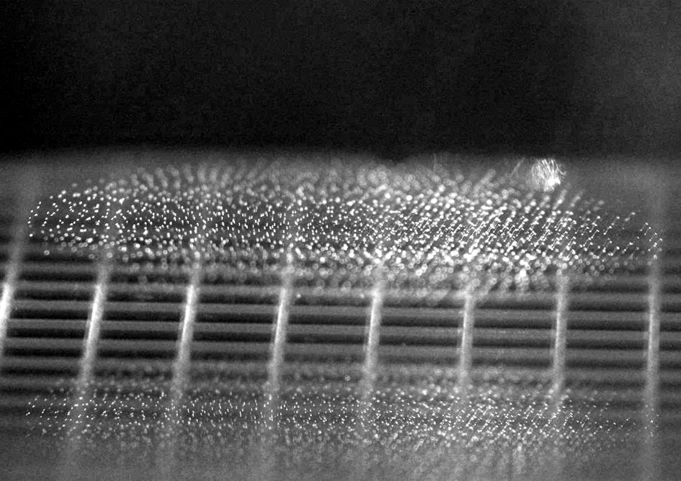
Fig. 2 This is a sample of a figure
Table 1 This is a sample of a table
Samples | Conditions | Results
XXX | A | 100
YYY | B | 80
ZZZ | C | 95
Table 2 This is another sample of a table
Samples | Conditions | Results
AAA | B | 70
BBB | C | 105

Figures are line drawings, photographs or computer-generated output. To maintain camera ready quality, use original drawings. Then convert them to raster or vector files in a popular format, for example, Windows Metafile (wmf), Enhanced Metafile (emf), Windows Bitmap (bmp), jpg (Joint Photographic Experts Group), Portable Network Graphics (png) and so on. Raster files with resolution of more than or equal to 300 dpi is acceptable. The tone should be 8-bit gray scale for monochrome raster images and 24-bit true color for color images. Lettering used in the figures is adjusted to the appropriate size after the figures are pasted into a manuscript. It is recommended that the lettering size after being pasted into the manuscript is 8 to 10 pt. The authors may be requested to modify the figures by the editorial board if the board decides that the figure is not suitable for publishing. Any symbols in the figures must be consistent with descriptions in the main body.
For table forms, the first and the last horizontal lines are 1 pt in thickness and the other lines are 0.5 pt in thickness. There is no vertical line on either side. All of the tabular lines are single. For Microsoft Word users, a special style named “JASMA_Table_Layout” is defined. Select a new blank line. Then select this style and the authors will get a new tabular form.
Every figure and table has a caption. The figure captions begin with Fig. and a sequential number. The table captions begin with Table and a sequential number. For the convenience of Microsoft Word users, “JASMA_Fig_Num”, “JASMA_Fig_Num_Cont”, “JASMA_Fig_Num_Multiline” and “JASMA_Fig_Num_Multiline_Cont” for figure captions are provided. “JASMA_Table_Num”, “JASMA_Table_Num_Cont”, “JASMA_Table_Num_Multiline” and “JASMA_Table_Num_Multiline_Cont” are also available for table captions. In these, the styles having “_Cont” are applied to multiple figures or tables in one block. The style with “_Cont” is applied to the first figure caption or later, while the one without “_Cont” is applied to the last one. On the other hand, the style with “_Cont” is applied to the second table caption or later, while the one without “_Cont” is applied to the first one. Please make sure that the lines to which the figure styles are applied differ from those to which the table styles are applied. The styles having “_Multiline” are applied to the multiline captions. After applying these styles, another font style “JASMA_Font_Caption” may be applied to recover the fonts of the caption body to the appropriate ones.
Sample forms are shown in this template as Table 1 and 2 for the tables and Fig. 2 and 3 for the figures. A special style for words inside a table, “JASMA_Table_Body” is also included since the spacing between the horizontal line on the top and the words are smaller than those between the line on the bottom and the words in Microsoft Word. This special style is included so that the spacing can be adjusted properly. This style may not be applicable to multiple line breaks in a single cell. If the authors refer to the figure or the table, the font style “JASMA_Font_Fig_Table” is available.
It is strongly recommended that figures and tables are placed at the top or the bottom of the main body if they fit in one column (82.2 mm wide). If they need more width than one column, the authors can place them as two-column layouts but only at the top or the bottom of pages.
The top line margin of the first table caption is 0 mm and that of the second caption or later is 5 mm. The bottom line margin of the table caption is 1.5 mm. The top line margin of the figure caption is 2 mm and the bottom one is 0 mm. Microsoft Word inserts an excess blank line just after a table but the authors can ignore this if they use a text box. In order to use the text box, select the tables or the figures including the captions first, and then insert the text box. Thus the authors will find a new text box having the selected items. After that, both the boundary lines and the paint of the text box are set to none. Place the text box in an appropriate position.
The authors should make sure that table and figures have appropriate spacing between them and the main body. If the authors use the text box as mentioned above, set the top margin of the text box to 6 mm if the text box is located at the bottom. If the text box is at the top, set the bottom margin to 6 mm for figures, but set the bottom margin to 2 mm for tables since a table has an excess blank line (the line height is about 4 mm). Unfortunately, Microsoft Word does not have a function to define a style for the text box. Therefore, the authors have to set those manually. The authors may want to use a layout frame. It will bring a similar result after adjusting some parameters, but the editorial board has not tested it.
3.8 References
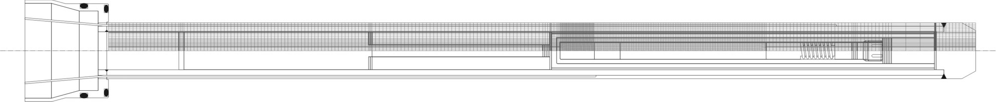
Fig. 3 This is another sample of a figure
Each reference has a unique reference number. The reference number should be sequential in order of appearance. In the main body, the reference number is described as a number with a right parenthesis, like 1). The reference number is superscripted in the main body without a font size change. If a comma or a period appears in a neighboring position, describe the numbers before the comma or the period. If there are two references, describe like 2,3). In the case of more than two references, describe like 4–6).
3.9 Numerical Values and Units
Use Arabic numerals to express numerical values. It is recommended to use the International System of Units (SI units). This is equivalent to Meter-Kilogram-Second (MKS) units. If the authors need to express acceleration normalized by earth gravity, use the upright capital letter “G”.
3.10 Equations
Equations should be expressed by the new standard equation editor included in MS-Word 2007 or later versions. This editor is a hybrid editor having a graphical user interface and accepting a LaTeX-like markup language. The font named Cambria Math is the standard font for equations. The font shape is much improved as compared with the older mathematical fonts. Therefore, authors must use Cambria Math. If the authors do not use Cambria Math, they will be requested to replace the fonts to Cambria Math. If the authors meet certain difficulty to use the standard equation editor, other methods for expressing equations may be acceptable if they paste the equations as raster images with resolution of more than 300 dpi.
If the acceleration of gravity is used as a physical constant, please use the single-story (or opentail) italic “”. There is no need to take care of the font design if the authors use the standard equation editor and the Cambria Math font to express it. Otherwise, they must pay attention to the font design. Although you can use any non-standard fonts in your manuscript, you must paste the fonts as raster images with more than 300 dpi so that the editors could see the fonts in machines in which Microsoft Windows OS is not installed.
Please use the new equation editor in any cases of an in-line equation, a single line equation and multiple lines equations. The equation is an example of an in-line equation. The next line is an example of a single line equation.
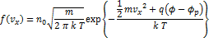 | (1)
To insert an in-line equation to the main body, please simply pressing the equation button at the insert ribbon. In single line or multiple lines equations, another way is recommended, that is, to select the insert ribbon first, then to click the downward triangle being just on the right side of the equation button. The authors can see a drop-down menu and selects an appropriate option such as JASMA Equation or JASMA Equation Continue. The former option should be used for the single line equation and the first equation in the multiple lines equations, while the latter one is for the second equation or later in the multiple lines equations. When the they select the option of JASMA Equation or JASMA Equation Continue, a new table with invisible ruled lines is inserted. This table is intended by four spaces (6.4 mm or 18 pt). The top margin of the equation except the in-line equation should be set to 4 mm in cases of the single line or the first equation in the multiple lines equations. The bottom margin should be always set to 3.5 mm. There is no need to take care of these margins if the authors use JASMA Equation or JASMA Equation Continue.
Each equation has a sequential number in parentheses. The equation number is right-aligned. When the authors refer to the equation in the main body, use Eq. or Eqs. and the equation number in parentheses, for example, Eq. (1) or Eqs. (2)–(4). There is no need to use bold face. This is different from Fig. and Table.
4. Part After Main Body
4.1 General
Acknowledgement, references and appendices are included after the main body. The appearance order is acknowledgement, references and appendices.
4.2 Headings
10 pt sans-serif fonts are used for the headings of acknowledgement, references and appendices. The heading of the acknowledgement is left-aligned. The heading of the references is center-aligned. The heading of the appendix if also center-aligned. If there are appendices, the left-aligned subheadings of Appendix 1, Appendix 2 and so on are included after the center-aligned heading of Appendices.
The top line margin of each heading of the acknowledgement, the references or the appendices is 4 mm. The bottom line margin is 1.5 mm. The top line margin of the subheadings of Appendix 1, Appendix 2 and so on is 2 mm, except for the position just after the heading of Appendices. The top margin of the subheading just after the heading of Appendices is 0 mm. The bottom margin is 1.5 mm.
The styles for Microsoft Word users are defined, that is, “JASMA_Acknowl_Heading” for the heading of the acknowledgement, “JASMA_Ref_Heading” for the headings of the references and the appendix, “JASMA_Append_Heading_Continue” for the first subheading of the appendix and “JASMA_Append_Heading” for the second subheading or thereafter.
4.3 Reference List
8 pt serif fonts are used in the reference list. Begin numbers corresponding to them in the main body with the right parenthesis. The numbers do not need to be superscripted. The format is the hanging indent with an indentation of 7 mm. The top line margin is 2 mm. For Microsoft Word users, the style “JASMA_Ref_List” is provided.
The reference list contains the author names, a colon as a separator, the journal name, the volume number, the issue number, the publishing year in parentheses, the starting page. All authors are included in the author names (do not use et al.). The Volume number is expressed in bold fonts.
4.3.1 Journals and Proceedings ¹⁾
The author name is written in the order of first name initial, middle initial and family name. If there are multiple authors, commas are inserted between the authors to separate them except for the last author. “and” is inserted before the last author. The separator between the author names and the journal name is one colon. If the reference is a part of proceedings ²⁾, the information on the place and the dates held are also necessary. If the journal is published in Japanese ³⁾ or other languages, the necessary information is translated into English. To represent the translation, the original language is added to the end of the list in parentheses.
4.3.3 Books ⁴⁾
The author names are the same as for journals. The separator is also a colon. After the separator, the name of the book is described. If editors exist, the editor names will be added after the book name. After that, the referenced chapters, the starting page, the publisher name, the publisher location and the publishing year are described. If the book is written in Japanese ⁵⁾ or other languages, translate the necessary information into English.
Acknowledgement
Acknowledgement is placed here.
References
1) A. F. Witt, H. C. Gatos, M. Lichtensteiger, M.C. Lavine and C. J. Herman: J. Electrochem. Soc., 122 (1975) 276.
2) K. W. Benz and G. Nagel: Proc. 5th Europ. Symp. Mat. Sci. under Microgravity, Schloss Elmau, FRG, Nov. 1984, 157.
3) T. Sukegawa and M. Kimura, J. Jpn. Soc. Microgravity Appl., 9 (1992) 89 (in Japanese).
4) J. J. Favier, J. D. Hunt and P. R. Sahm: Fluid Sciences and Materials Science in Space, ed. H. U. Walter, Chap. 14, 477, Springer–Verlag, Berlin, 1987.
5) Y. Furukawa: Research Genealogy of Snow and Ice, Snow Crystals, 49, Jpn. Soc. Snow and Ice, 2009 (in Japanese).
Appendices
Appendix 1
Appendix is described in this area.
Appendix 2
If there are multiple appendices, subheadings such as Appendix 1 and Appendix 2 are used. In such a case, the heading of Appendices cannot be omitted.

