日本マイクログラビティ応用学会（JASMAC Proceedings）原稿作成用テンプレート
〇微小一郎，生命花子，流体次郎（燃焼大），細胞三郎（プラズマ）
Template for Journal of the Japan Society of Microgravity Application (JASMAC Proceedings)
○Ichiro BISHO, Hanako SEIMEI , Jiro RYUTAI (Combustion Univ.), Saburo SAIBO (Plasma Co., Ltd.)

1. Layout
The manuscript should be typewritten in English on one side of A4 paper. The standard font in this template is serif such as Time New Roman or Times (9pt). Left and right margins are 25 mm, Top and bottom are 30 mm. The main body should be formatted in two columns with justification. The gap between the two columns is 7.5 mm.
This template is provided for JASMAC Proceedings. The recommended word processor for this template is Microsoft Word. For authors’ convenience, styles starting with JASMAC are defined in this template. If authors want to use other word processors or text formatters, please copy all the layout of this template as closely as possible.

2. Forms
2.1 Headings
The headings have sequential numbers such as 1(10pt). for the section headings, 1.1(9pt) for the subsections and 1.1.1 for the sub-subsections.
2.2 Symbol of Gravity
If authors want to express microgravity as a noun by using symbols, use g. “ is a Symbol Italic font in Microsoft Word or Symbol Oblique font in more general environments, while “g” is a small letter with an upright typeface.
Table 1 This is a sample of a table
Samples | Conditions | Results
XXX | A | 100
YYY | B | 80
ZZZ | C | 95

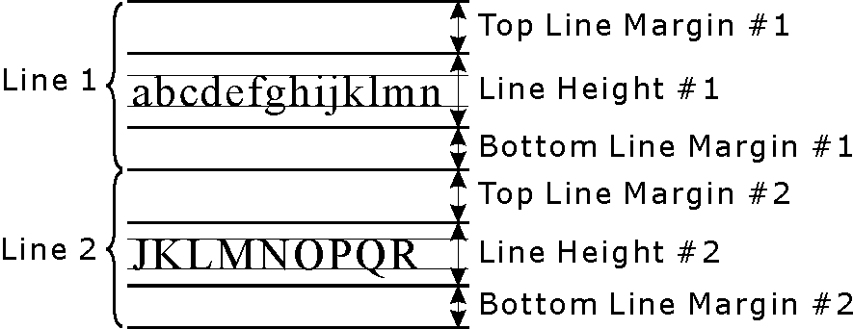
Fig. 1 This is a sample of a figure
2.3 Figures and Tables
Every figure and table has a caption. Sample forms are shown in this template as Fig. 1and Table 1.
2.4 References
Each reference has a unique reference number. The reference number should be sequential in order of appearance. The reference number is described as a number with a right parenthesis, like ¹⁾.
2.5 Numerical Values and Units
Use Arabic numerals to express numerical values. It is recommended to use the International System of Units (SI units). This is equivalent to Meter-Kilogram-Second (MKS) units. If the authors need to express acceleration normalized by earth gravity, use the upright capital letter “G”.
2.6 Equations
The authors should try to use fonts that are easily recognizable. For example, “” (v in Times New Roman Italic) should not be used since “” (nu in Greek Italic) is very similar in appearance. In this case, the authors should try another font such as “” (Book Antiqua Italic) instead of “v”. If the authors use the acceleration of gravity as a physical constant, use the single-story (or opentail) italic “”.
Use fonts for mathematical equations in any in-line, single-line and multiple equations. For example, this equation 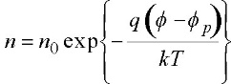 is an example of an in-line equation. The next line is an example of a single-line equation.

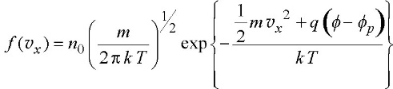 (1)
In this template, these equations are pasted as raster images of a resolution of 300 dpi for the same reason as those of the previous fonts.

References
1) The author names, a colon as a separator, the journal name, the volume number, the issue number, the publishing year in parentheses, the starting page. All authors are included in the author names (do not use et al.). The Volume number is expressed in bold fonts (8pt).
2) A. F. Witt, H. C. Gatos, M. Lichtensteiger, M.C. Lavine and C. J. Herman: J. Electrochem. Soc., 122 (1975) 276.
3) K. W. Benz and G. Nagel: Proc. 5th Europ. Symp. Mat. Sci. under Microgravity, Schloss Elmau, FRG, Nov. 1984, 157.

